
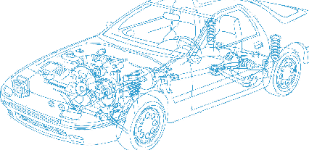

Caledonian Cables

Automotive Cable

CAVS
Application:
This PVC insulated single-core low tension cable is used for automotive wiring.
Construction:


Copper conductor PVC insulation

Conductor: Cu-ETP1 according to JIS C 3102
Insulation: PVC
Standard Compliance: JASO D 611-94
Technical Parameters:
Operating temperature:–40 °C to +80 °C

 | Conductor |  |  | Insulation | Cable
Nominal Cross- section | No. and Dia. of Wires | Diameter max. | Electrical  Resistance at 20°C max. | Thickness Wall nom. | Overall Diameter min. | Overall Diameter max. | Weight approx.
mm2 | No./mm | mm | mΩ/m | mm | mm | mm | kg/km
1 x0.30 | 7/0.26 | 0.70 | 50.20 | 0.35 | 1.40 | 1.50 | 3
1 x0.50 | 7/0.32 | 0.90 | 32.70 | 0.35 | 1.60 | 1.70 | 5
1 x0.85 | 11/0.32 | 1.10 | 20.80 | 0.35 | 1.80 | 1.90 | 7
1 x1.25 | 16/0.32 | 1.40 | 14.30 | 0.35 | 2.10 | 2.20 | 10
*Note: Other configurations, sizes, colors and length not specified herein are available upon request.

www.caledonian-cables.co.uk www.addison-cables.com 35

