
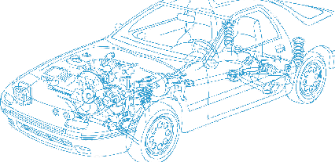

Caledonian Cables

Automotive Cable

EB/HDEB
Application:
This PVC insulated single-core cable is used in low voltage circuits of battery for automobiles.
Construction:


Copper conductor PVC insulation

Conductor: Cu-ETP1 according to JIS C 3102
Insulation: PVC
Standard Compliance: JIS C 3406
Features:
EB wires is for grounding (-side) and thin type; It consists of complex stranded conductors (flexible type).
HDEB wires are thicker type than EB wires to provide increased mechanical strength.
Technical Parameters:
Operating temperature: –40 °C to +100 °C

EB
 | Conductor |  |  | Insulation | Cable
Nominal Cross- section | No. and Dia. of Wires | Diameter max. | Electrical  Resistance at 20°C max. | Thickness Wall nom. | Overall Diameter min. | Overall Diameter max. | Weight approx.
mm2 | No./mm | mm | mΩ/m | mm | mm | mm | kg/km
1 x5 | 63/0.32 | 3.10 | 3.58 | 0.60 | 4.30 | 4.70 | 57
1 x9 | 112/0.32 | 4.20 | 2.00 | 0.60 | 5.40 | 5.80 | 95
1 x15 | 171/0.32 | 5.30 | 1.32 | 0.60 | 6.50 | 6.90 | 147
1 x20 | 247/0.32 | 6.50 | 0.92 | 0.60 | 7.70 | 8.00 | 207
1 x30 | 361/0.32 | 7.80 | 0.63 | 0.60 | 9.00 | 9.40 | 303
1 x40 | 494/0.32 | 9.10 | 0.46 | 0.60 | 10.30 | 10.80 | 374
1 x50 | 608/0.32 | 10.10 | 0.37 | 0.60 | 11.30 | 11.90 | 473

www.caledonian-cables.co.uk www.addison-cables.com 37


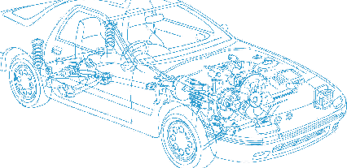
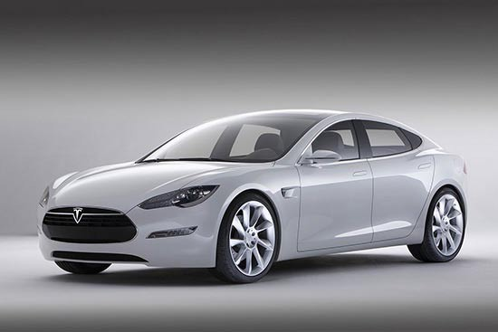

Caledonian Cables
Automotive Cable

EB
 | Conductor |  |  | Insulation | Cable
Nominal Cross- section | No. and Dia. of Wires | Diameter max. | Electrical  Resistance at 20°C max. | Thickness Wall nom. | Overall Diameter min. | Overall Diameter max. | Weight approx.
mm2 | No./mm | mm | mΩ/m | mm | mm | mm | kg/km
1 x60 | 741/0.32 | 11.10 | 0.31 | 0.60 | 12.30 | 12.90 | 570
HDEB
1 x9 | 112/0.32 | 4.20 | 2.00 | 1.00 | 6.20 | 6.50 | 109
1 x15 | 171/0.32 | 5.30 | 1.32 | 1.10 | 7.50 | 8.00 | 161
1 x20 | 247/0.32 | 6.50 | 0.92 | 1.10 | 8.70 | 9.30 | 225
1 x30 | 361/0.32 | 7.80 | 0.63 | 1.40 | 10.60 | 11.30 | 331
1 x40 | 494/0.32 | 9.10 | 0.46 | 1.40 | 11.90 | 12.60 | 442
1 x60 | 741/0.32 | 11.10 | 0.31 | 1.60 | 14.30 | 15.10 | 655
*Note: Other configurations, sizes, colors and length not specified herein are available upon request.

38 www.caledonian-cables.co.uk www.addison-cables.com

