
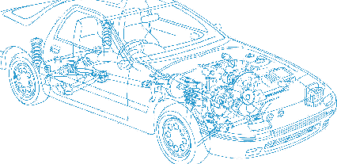

Caledonian Cables

Automotive Cable

FL4G11Y
Application:
This EVA insulated , PUR sheathed multi-cores cable is used for ABS braking systems, wiring inside the engine compartment.
Construction:



EVA insulation Copper conductor
PUR sheath

Conductor: Cu-ETP1 tinned according to DIN EN 13602
Insulation: Ethylene vinyl acetate (EVA)
Sheath: Polyurethane (PUR)
Sheath colour: black
Standard Compliance: ISO 6722
Technical Parameters:
Operating temperature: –40 °C to +125 °C
Special Properties:
Good flexibility and Good reversed bending strength. Conductors with 3 and 4 cores for additional functions. Also suitable for wiring inside the engine compartment

 | Conductor |  |  | Insulation |  | Cable
Nominal Cross- section | No. and Dia. of Wires | Diameter max. | Electrical  Resistance at 20°C max. | Thickness Wall nom. | Diameter of Core | Sheath Thickness | Overall Diameter min. | Overall Diameter max. | Weight approx.
mm2 | No./mm | mm | mΩ/m | mm | mm | mm | mm | mm | kg/km
2 x 0.50 | 28/0.16 | 1.00 | 40.10 | 0.35 | 1.65 | 0.55 | 4.10 | 4.50 | 27
2 x 0.50 | 28/0.16 | 1.00 | 40.10 | 0.35 | 1.65 | 0.90 | 5.00 | 5.30 | 34
2 x0.75 | 40/0.16 | 1.10 | 27.10 | 0.5 | 2.20 | 0.90 | 5.90 | 6.45 | 49
3 x0.50 | 28/0.16 | 1.00 | 40.10 | 0.35 | 1.65 | 0.80 | 5.00 | 5.40 | 39
4 x0.50 | 28/0.16 | 1.00 | 40.10 | 0.35 | 1.65 | 0.60 | 5.00 | 5.40 | 42
*Note: Other configurations, sizes, colors and length not specified herein are available upon request.

24 www.caledonian-cables.co.uk www.addison-cables.com

