
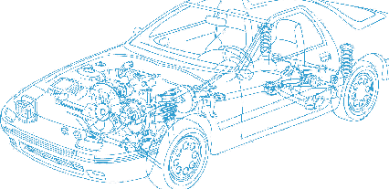

Caledonian Cables

Automotive Cable

FL6Y2G
Application:
This FEP insulated multi-cores cable is used for automobiles.
Construction:



FEP insulation
Soft-annealed copper conductor

Silicone rubber,cross-linked sheath

Conductor:
Cu-ETP1 or bare according to DIN EN 13602
Insulation:
Fluorinated ethylene propylene(FEP) insulation
Sheath:
Siliconne rubber,cross-linked according to ISO 14572 class F
Standard:
ISO 6722 Class F
Technical Parameters:
Operating temperature: –40°C to +210°C

 | Conductor |  |  | Insulation | Cable
Nominal cross- section | No. and Dia. of Wires | Diameter max. | Electrical  resistance at 20°C max. | Thickness Wall nom. | Sheath Thickness | Overall Diameter min. | Overall Diameter max. | Weight approx.
mm2 | No./mm | (mm) | mΩ/m | (mm) | (mm) | mm | mm | kg/km
2x0.35 | 12/0.21 | 0.8 | 52 | 0.4 | 0.53 | 4.6 | 5 | 32
2x0.25 | 24/0.16 | 0.7 | 86.5 | 0.4 | 0.53 | 3.4 | 3.8 | 24

Note: Other configurations, sizes, colors and length not specified herein are available upon request.

www.caledonian-cables.co.uk www.addison-cables.com 27

