
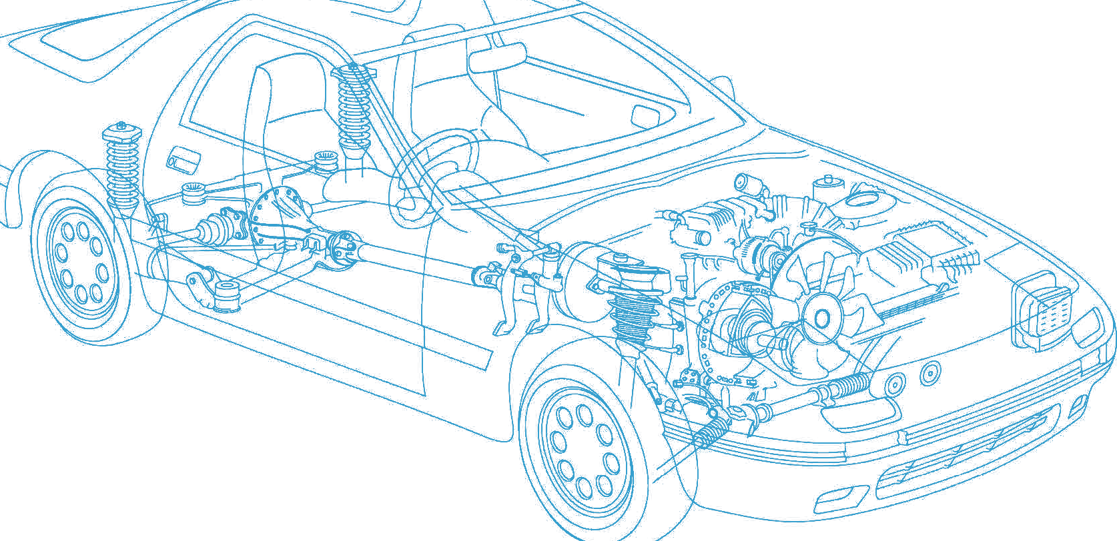

Caledonian Cables

Automotive Cable

FLALRYW

Application and Description:

This PVC insulated automotive cable is suitable for application inside the engine compartment.

Cable Construction:



Aluminium conductor PVC insulation

Conductor:

Aluminium 99.7%≥1.25 mm2
Aluminium alloy < 1.25 mm2

Insulation:PVC Standard:ISO 6722 Class C Special properties:
Hot pressure resistance
Considerable weight savings compared to copper

Technical Parameters:

Operating temperature: –40°C to +125°C

 | Conductor Construction |  |  | Insulation | Cable
Nominal Cross- section | No. and Dia. of Wires | Diameter of Conductor max. | Electrical  Resistance at 20°C  max. | Nominal Thickness | Overall Diameter min. | Overall Diameter max. | Weight Approx.
mm2 | no./mm | mm | mΩ/m | mm | mm | mm | kg/km
1x0.75 | 11/0.3 | 1.3 | 43.6 | 0.24 | 1.7 | 1.9 | 4
1x1.00 | 16/0.29 | 1.5 | 32.7 | 0.24 | 1.9 | 2.1 | 5
1x1.25 | 16/0.32 | 1.7 | 24.8 | 0.24 | 2.1 | 2.3 | 6
1x1.50 | 16/0.35 | 1.8 | 21.2 | 0.24 | 2.2 | 2.4 | 7

42 www.caledonian-cables.co.uk www.addison-cables.com

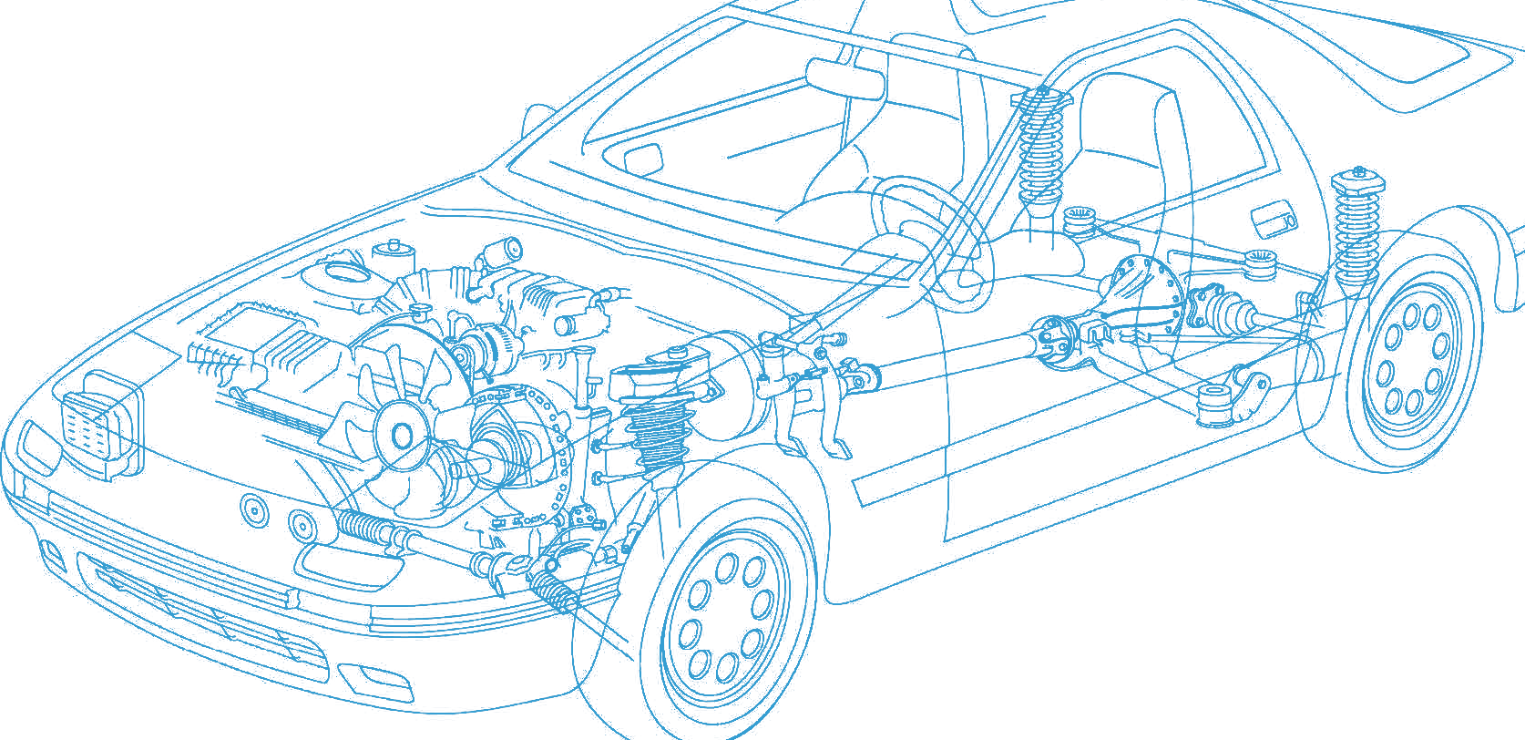





Caledonian Cables

Automotive Cable

 | Conductor Construction |  |  | Insulation | Cable
Nominal Cross- section | No. and Dia. of Wires | Diameter of Conductor max. | Electrical  Resistance at 20°C  max. | Nominal Thickness | Overall Diameter min. | Overall Diameter max. | Weight Approx.
mm2 | no./mm | mm | mΩ/m | mm | mm | mm | kg/km
1x2.0 | 15/0.42 | 2.0 | 15.7 | 0.28 | 2.5 | 2.8 | 9
1x2.5 | 19/0.43 | 2.2 | 12.7 | 0.28 | 2.7 | 3.0 | 12
1x3.0 | 23/0.42 | 2.4 | 10.2 | 0.32 | 3.1 | 3.4 | 14
1x4.0 | 30/0.42 | 2.8 | 7.85 | 0.32 | 3.4 | 3.7 | 17
1x5.0 | 36/0.42 | 3.1 | 6.57 | 0.32 | 3.9 | 4.2 | 19
1x6.0 | 45/0.42 | 3.4 | 5.23 | 0.32 | 4.0 | 4.3 | 23
1x8.0 | 59/0.42 | 4.3 | 3.97 | 0.32 | 4.6 | 5.0 | 29
1x10.0 | 50/0.52 | 4.5 | 3.03 | 0.48 | 5.3 | 6.0 | 43
1x12.0 | 60/0.52 | 5.4 | 2.53 | 0.48 | 5.8 | 6.5 | 50
1x16.0 | 78/0.52 | 5.8 | 1.93 | 0.52 | 6.4 | 7.2 | 63

Note: Other configurations, sizes, colors and length not specified herein are available upon request.

www.caledonian-cables.co.uk www.addison-cables.com 43

