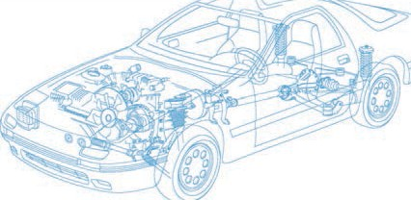

Caledonian Cables

Automotive Cable

FLR13Y-A

Application and Description:

This TPE insulated low-tension automotive cable is used in motorcycles and other motor vehicles for starting ,charging,lighting,signal and instrument panel circuits.

Cable Construction:


Copper conductor TPE-E insulation

Conductor:Cu-ETP1 bare according to DIN EN 13602

Insulation:TPE-E

Standard:

ISO 6722 Class D

Special properties: Limited resistance to hydrolysis Technical Parameters:
Operating temperature: –40°C to +150°C

 | Conductor Construction |  |  | Insulation | Cable
Nominal cross- section | No. and Dia. of Wires | Diameter of Conductor max. | Electrical  resistance at 20°C  max. | Nominal thickness | Overall Diameter Min. | Overall Diameter Max. | Weight approx.
mm2 | No./mm | mm | mΩ/m | mm | mm | mm | kg/km
1x 0.22 | 7/0.21 | 0.7 | 84.8 | 0.2 | 1.1 | 1.2 | 3
1x 0.35 | 7/0.26 | 0.8 | 52 | 0.2 | 1.2 | 1.6 | 5
1x 0. 5 | 19/0.19 | 1.0 | 37.1 | 0.22 | 1.4 | 1.6 | 6
1x 0. 75 | 19/0.23 | 1.2 | 24.7 | 0.24 | 1.7 | 1.9 | 9
1x1 | 19/0.26 | 1.35 | 18.5 | 0.24 | 1.9 | 2.1 | 11
1x 1.5 | 19/0.32 | 1.7 | 12.7 | 0.24 | 2.2 | 2.4 | 17
1x 2 | 19/0.37 | 2.0 | 9.42 | 0.28 | 2.5 | 2.8 | 21
1x 2.5 | 19/0.41 | 2.2 | 7.6 | 0.28 | 2.7 | 3.0 | 26
Note: Other configurations, sizes, colors and length not specified herein are available upon request.
www.caledonian-cables.co.uk www.addison-cables.com 33

