
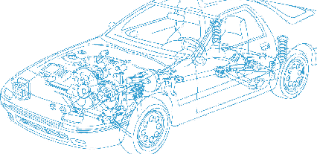

Caledonian Cables

Automotive Cable

FLR13Y11Y
Application:
This TPE-E insulated , TPE-U sheathed low tension multi-cores cable is used for ABS systems, it has excellent abrasion resistance and better resistance to bending fatigue.
Construction:



TPE-E insulation Copper conductor
TPE-U sheath

Conductor: Cu-ETP1 according to DIN EN13602 Insulation: Thermoplasticity polyester (TPE-E) Sheath: Thermoplasticity polyurethane (TPU) Standard Compliance: ISO 6722
Technical Parameters:
Operating temperature: –40 °C to +125 °C

 | Conductor |  |  | Insulation |  | Cable
Nominal Cross- section | No. and Dia. of Wires | Diameter max. | Electrical  Resistance at 20°C max. | Thickness Wall nom. | Diameter of Core | Sheath Thickness | Overall Diameter min. | Overall Diameter max. | Weight approx.
mm2 | No./mm | mm | mΩ/m | mm | mm | mm | mm | mm | kg/km
2 x 0.50 | 28/0.16 | 1.00 | 37.10 | 0.20 | 1.40 | 0.60 | 3.85 | 4.15 | 22
2 x 0.50 | 28/0.16 | 1.00 | 37.10 | 0.20 | 1.40 | 0.85 | 4.35 | 4.65 | 27
2 x 0.50 | 28/0.16 | 1.00 | 37.10 | 0.35 | 1.70 | 0.80 | 4.80 | 5.20 | 32
2 x 0.60 | 80/0.11 | 1.20 | 24.70 | 0.20 | 1.45 | 0.80 | 4.35 | 4.65 | 28
2 x 0.75 | 42/0.16 | 1.20 | 27.10 | 0.30 | 1.80 | 1.30 | 6.00 | 6.40 | 48
2 x 0.75 | 96/0.10 | 1.20 | 27.10 | 0.30 | 1.80 | 1.30 | 6.00 | 6.40 | 62
*Note: Other configurations, sizes, colors and length not specified herein are available upon request.

www.caledonian-cables.co.uk www.addison-cables.com 21

