
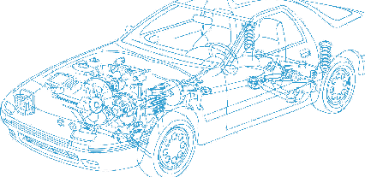

Caledonian Cables

Automotive Cable

FLR2X11Y
Application:
This XLPE insulated, PUR sheathed multi-cores cable is used for ABS systems. it has good bending strength properties.
Construction:



XLPE insulation Copper conductor
PUR sheath

Conductor: Cu-ETP1 bare or tinned according to DIN EN 13602
Insulation: Crosslinked polyethylene (XLPE) Sheath: Polyether polyurethane (PUR) Sheath colour: black
Standard Compliance: ISO 6722
Technical Parameters:
Operating temperature: –40 °C to +125 °C
Special Properties:
Special conductor highly tensile and bending resistant Cu-alloy, Cadmium-free.

 | Conductor |  |  | Insulation |  | Cable
Nominal Cross- section | No. and Dia. of Wires | Diameter max. | Electrical  Resistance at 20°C Bare/tinned max. | Thickness Wall nom. | Diameter of Core | Sheath Thickness | Overall Diameter min. | Overall Diameter max. | Weight approx.
mm2 | No./mm | mm | mΩ/m | mm | mm | mm | mm | mm | kg/km
2 x0.35 | 12/0.21 | 0.90 | 52.00/54.50 | 0.25 | 1.35 | 0.50 | 3.50 | 3.90 | 18
2 x0.50 | 19/0.19 | 1.00 | 37.10/40.10 | 0.30 | 1.50 | 0.65 | 4.20 | 4.60 | 25
2 x0.50 | 64/0.10 | 1.00 | 38.20/40.10 | 0.35 | 1.60 | 0.95 | 5.00 | 5.40 | 36
2 x0.75 | 42/0.16 | 1.20 | 24.70/27.10 | 0.50 | 2.20 | 0.90 | 6.00 | 6.40 | 46
*Note: Other configurations, sizes, colors and length not specified herein are available upon request.

www.caledonian-cables.co.uk www.addison-cables.com 25

