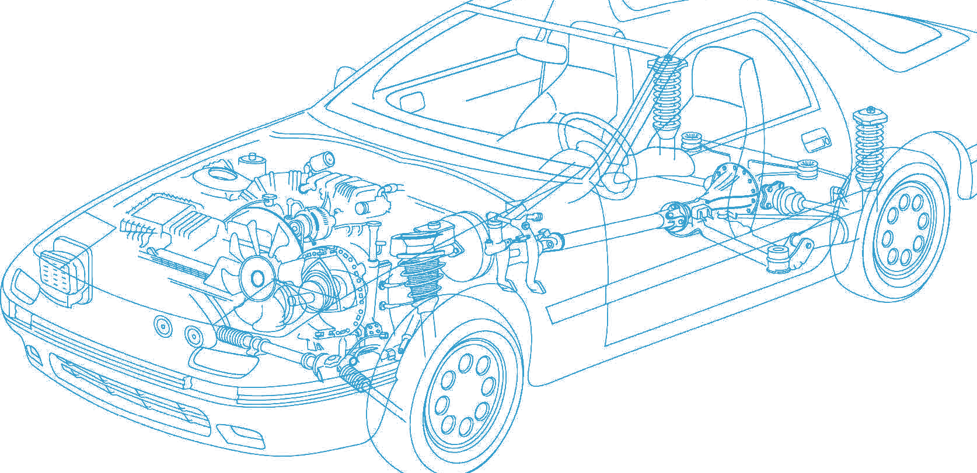

Caledonian Cables

Automotive Cable

FLR5Y-A

Application:

This PTFE insulated low-tension automotive cable is used in motorcycles and other motor vehicles for starting ,charging,lighting,signal and instrument panel circuits.

Construction:


Copper conductor PTFE insulation

Conductor:Cu-ETP1 bare according to DIN EN 13602

Insulation:PTFE Standard:ISO 6722 Class H Special properties:
Excellent resistance to chemicals

Technical Parameters:

Operating temperature: –90°C to +260°C

 | Conductor Construction |  |  | Insulation | Cable
Nominal Cross- section | No. and Dia. of Wires | Diameter of Conductor max. | Electrical  Resistance at 20°C  max. | Nominal Thickness | Overall Diameter min. | Overall Diameter max. | Weight Approx.
mm2 | no./mm | mm | mΩ/m | mm | mm | mm | kg/km
1x0.22 | 7/0.21 | 0.7 | 87.9 | 0.20 | 1.1 | 1.2 | 3
1x0.35 | 7/0.27 | 0.8 | 56.8 | 0.20 | 1.25 | 1.35 | 5
1x0.5 | 19/0.19 | 1.0 | 38.6 | 0.22 | 1.4 | 1.6 | 6
1x0.75 | 19/0.24 | 1.2 | 25.7 | 0.24 | 1.7 | 1.9 | 10
1x1 | 19/0.27 | 1.35 | 19.3 | 0.24 | 1.75 | 1.95 | 11
1x1.5 | 19/0.33 | 1.7 | 13.2 | 0.24 | 2.1 | 2.3 | 17
1x2.5 | 19/0.41 | 2.2 | 7.92 | 0.28 | 2.5 | 2.8 | 25
Note: Other configurations, sizes, colors and length not specified herein are available upon request.

www.caledonian-cables.co.uk www.addison-cables.com 27

