
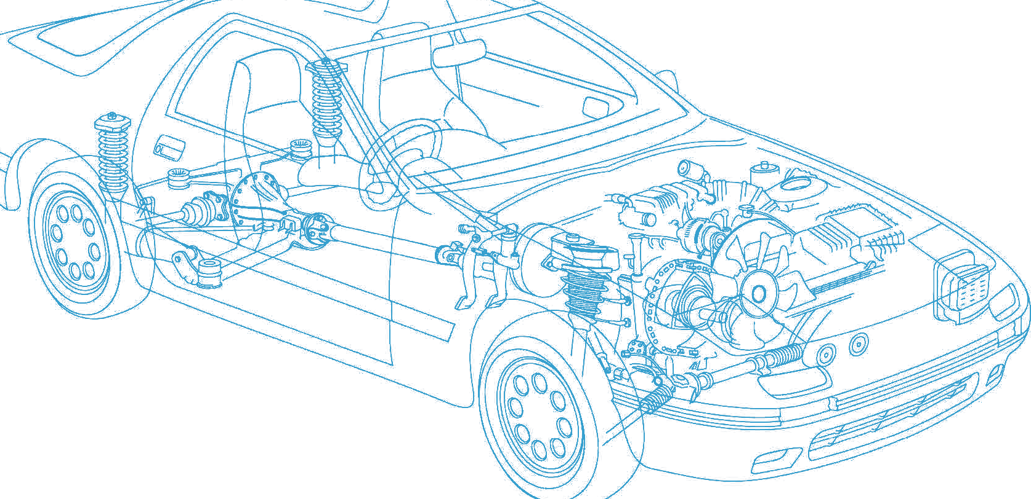

Caledonian Cables

Automotive Cable

FLR5Y-B

Application:

This PTFE insulated low-tension automotive cable is used in motorcycles and other motor vehicles for starting ,charging,lighting,signal and instrument panel circuits.

Construction:


Copper conductor PTFE insulation

Conductor:Cu-ETP1 bare according to DIN EN 13602

Insulation:PTFE Standard:ISO 6722 Class H Special properties:
Excellent resistance to chemicals

Technical Parameters:

Operating temperature: –90°C to +260°C

 | Conductor Construction |  |  | Insulation | Cable
Nominal Cross- section | No. and Dia. of Wires | Diameter of Conductor max. | Electrical  Resistance at 20°C max. | Nominal Thickness | Overall Diameter min. | Overall Diameter max. | Weight Approx.
mm2 | no./mm | mm | mΩ/m | mm | mm | mm | kg/km
1x0.35 | 12/0.21 | 0.9 | 87.9 | 0.20 | 1.25 | 1.35 | 5
1x0.5 | 16/0.21 | 1.0 | 56.8 | 0.22 | 1.4 | 1.6 | 6
1x0.75 | 24/0.21 | 1.2 | 38.6 | 0.24 | 1.7 | 1.9 | 9
1x1 | 32/0.21 | 1.4 | 25.7 | 0.24 | 1.75 | 1.95 | 11
1x1.5 | 30/0.26 | 1.7 | 19.3 | 0.24 | 2.1 | 2.3 | 16
1x2.5 | 50/0.26 | 2.2 | 13.2 | 0.28 | 2.5 | 2.8 | 26
1x4 | 56/0.31 | 2.75 | 4.91 | 0.32 | 3.05 | 3.35 | 40
1x6 | 84/0.31 | 3.4 | 3.27 | 0.32 | 3.85 | 4.15 | 61
Note: Other configurations, sizes, colors and length not specified herein are available upon request.

28 www.caledonian-cables.co.uk www.addison-cables.com

