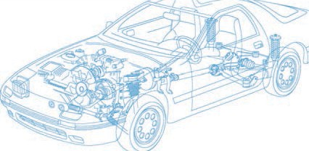

Caledonian Cables

Automotive Cable

FLR6Y-A

Application and Description:

This FEP insulated low-tension automotive cable is used in motorcycles and other motor vehicles for starting ,charging,lighting,signal and instrument panel circuits.

Cable Construction:


Copper conductor FEP insulation

Conductor:Cu-ETP1 bare/tinned according to DIN EN 13602

Insulation:FEP

Standard:

ISO 6722 Class F Special properties: Good Thermal properties
Technical Parameters:

Operating temperature: –65°C to +210°C

 | Conductor Construction |  |  | Insulation | Cable
Nominal cross- section | No. and Dia. of Wires | Diameter of Conductor max. | Electrical  resistance at 20°C  bare/tinned max. | Nominal thickness | Overall Diameter Min. | Overall Diameter Max. | Weight approx.
mm2 | No./mm | mm | mΩ/m | mm | mm | mm | kg/km
1x 0.35 | 7/0.26 | 0.8 | 54.4/55.5 | 0.2 | 1.2 | 1.3 | 4
1x 0.5 | 19/0.19 | 1.0 | 37.1/38.2 | 0.22 | 1.4 | 1.6 | 7
1x 0.75 | 19/0.23 | 1.2 | 24.7/25.4 | 0.24 | 1.7 | 1.9 | 9
1x1 | 19/0.26 | 1.35 | 18.5/19.1 | 0.24 | 1.9 | 2.1 | 12
1x 1.5 | 19/0.32 | 1.7 | 12.7/13.0 | 0.24 | 2.2 | 2.4 | 17
1x 2.5 | 19/0.41 | 2.2 | 7.6/7.82 | 0.28 | 2.7 | 3.0 | 27
Note: Other configurations, sizes, colors and length not specified herein are available upon request.

www.caledonian-cables.co.uk www.addison-cables.com 29

