
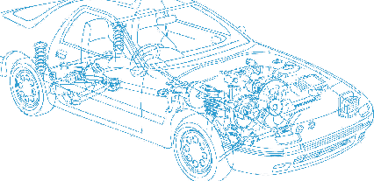

Caledonian Cables

Automotive Cable

FLRY-A
Application:
This PVC insulated single-core cable with symmetrical conductor structure (type A) and thin wall is used
for automobiles, Motorcycles electrical equipment in high temperature condition.
Construction:


Copper conductor PVC insulation

Conductor: Cu-ETP1 bare or tinned copper according to DIN EN13602
Insulation: PVC
Standard Compliance: ISO 6722 Class B
Technical Parameters:
Operating temperature: –40°C to 105°C

 | Conductor |  |  | Insulation | Cable
Nominal Cross- section | No. and Dia. of Wires | Diameter max. | Resistance at  20°C  Bare/Tinned max. | Thickness Wall min. | Overall Diameter max. | Weight approx.
mm2 | No./mm | mm | mΩ/m | mm | mm | kg/km
1x0.22 | 7/0.21 | 0.70 | 84.80/86.50 | 0.20 | 1.20 | 3
1x0.35 | 7/0.26 | 0.80 | 52.00/54.50 | 0.20 | 1.30 | 5
1x0.50 | 19/0.19 | 1.00 | 37.10/38.20 | 0.22 | 1.60 | 7
1x0.75 | 19/0.23 | 1.20 | 24.70/25.40 | 0.24 | 1.90 | 9
1x1.00 | 19/0.26 | 1.35 | 18.50/19.10 | 0.24 | 2.10 | 11
1x1.50 | 19/0.32 | 1.70 | 12.70/13.00 | 0.24 | 2.40 | 16
1x2.00 | 19/0.37 | 2.00 | 9.42/9.69 | 0.24 | 2.60 | 23
1x2.50 | 19/0.41 | 2.20 | 7.60/7.80 | 0.28 | 3.00 | 26
*Note: Other configurations, sizes, colors and length not specified herein are available upon request.

14 www.caledonian-cables.co.uk www.addison-cables.com

