
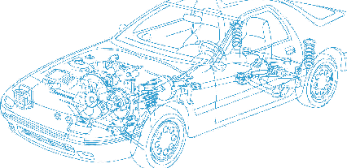

Caledonian Cables

Automotive Cable

FLRY-B
Application:
This PVC insulated single-core cable with symmetrical conductor structure (type B) and thin wall is used
for automobiles, Motorcycles electrical equipment in high temperature condition
Construction:


Copper conductor PVC insulation

Conductor: Cu-ETP1 bare or tinned according to DIN EN13602
Insulation: PVC
Standard Compliance: ISO 6722 Class B LV112
Technical Parameters:
Operating temperature: –40°C to 105°C

 | Conductor |  |  | Insulation | Cable
Nominal Cross- section | No. and Dia. of Wires | Diameter max. | Resistance at  20°C  Bare/Tinned max. | Thickness Wall min. | Overall Diameter | Weight approx.
mm2 | No./mm | mm | mΩ/m | mm | mm | kg/km
1x0.35 | 12/0.21 | 0.90 | 52.00/5.50 | 0.20 | 1.40 | 5
1x0.50 | 16/0.21 | 1.00 | 37.10/38.20 | 0.22 | 1.60 | 7
1x0.75 | 24/0.21 | 1.20 | 24.70/25.40 | 0.24 | 1.90 | 9
1x1.00 | 32/0.21 | 1.35 | 18.50/19.10 | 0.24 | 2.10 | 11
1x1.50 | 30/0.26 | 1.70 | 12.70/13.00 | 0.24 | 2.40 | 16
1x2.00 | 30/0.31 | 1.90 | 9.31/9.59 | 0.24 | 2.60 | 22
1x2.50 | 50/0.26 | 2.20 | 7.60/7.80 | 0.28 | 3.00 | 26
1x3.00 | 45/0.31 | 2.40 | 6.21/6.40 | 0.28 | 3.20 | 33
1x4.00 | 56/0.31 | 2.75 | 4.70/4.80 | 0.32 | 3.70 | 42
1x6.00 | 84/0.31 | 3.30 | 3.10/3.20 | 0.32 | 4.30 | 61
1x10.00 | 80/0.41 | 4.50 | 1.82/1.85 | 0.48 | 6.00 | 108
1x16.00 | 126/0.41 | 6.30 | 1.16/1.18 | 0.52 | 7.90 | 170
1x25.00 | 196/0.41 | 7.80 | 0.74/0.76 | 0.52 | 9.40 | 265
*Note: Other configurations, sizes, colors and length not specified herein are available upon request.

www.caledonian-cables.co.uk www.addison-cables.com 15

