
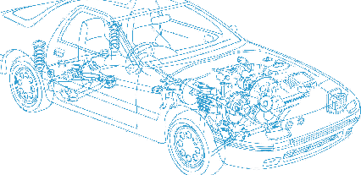

Caledonian Cables

Automotive Cable

FLRYCY
Application:
This PVC insulated, PVC sheathed multi-cores cable is used for car communication cable.
Construction:






Drain wire PVC insulation
Copper conductor
Soft-annealed copper wires PVC sheath

Conductor: Cu-ETP1 according to DIN EN 13602
Insulation: PVC
Drain wire: Drain wire of tinned copper wires of Cu-ETP1
Shielding: Soft-annealed copper wires CU-ETP1 or tin coated soft-annealed copper wires according to DIN 40500 and DIN EN 13602
Sheath: PVC
Standard Compliance: ISO 6722
Technical Parameters:
Operating temperature: –40 °C to +105 °C

 | Conductor |  |  | Insulation |  | Cable
Nominal Cross- section | No. and Dia. of Wires | Diameter max. | Electrical  Resistance at 20°C Bare/tinned max. | Thickness Wall nom. | Diameter of Core | Sheath Thickness | Overall Diameter min. | Overall Diameter max. | Weight approx.
mm2 | No./mm | mm | mΩ/m | mm | mm | mm | mm | mm | kg/km
9 x0.08 | 10/0.11 | 0.45 | 35.30/36.50 | 0.20 | 0.80 | 0.60 | 4.60 | 4.90 | 38
10 x0.25 | 14/0.16 | 0.70 | 84.80/86.50 | 0.20 | 1.10 | 0.60 | 5.80 | 6.20 | 68
5 x0.35 | 19/0.16 | 0.80 | 52.00/54.50 | 0.25 | 1.30 | 0.50 | 4.70 | 5.10 | 47
8 x0.35 | 19/0.16 | 0.80 | 52.00/54.50 | 0.25 | 1.25 | 0.65 | 5.90 | 6.30 | 75
10 x0.35 | 19/0.16 | 0.80 | 52.00/54.50 | 0.25 | 1.25 | 0.65 | 6.50 | 6.90 | 83

Note: Other configurations, sizes, colors and length not specified herein are available upon request.

26 www.caledonian-cables.co.uk www.addison-cables.com

