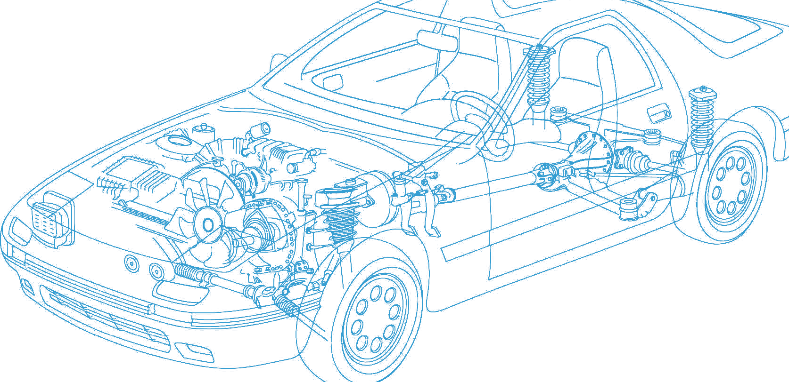

Caledonian Cables

Automotive Cable

FLRYDY

Application:

This PVC insulated low-tension automotive cable is used in motorcycles and other motor vehicles for starting ,charging,lighting,signal and instrument panel circuits.

Construction:


Copper wire spiral screen Copper conductor

PVC insulation PVC sheath

Conductor:Cu-ETP1 bare according to DIN EN 13602

Insulation:PVC

Screen:Copper wire spiral shield

Sheath:PVC

Standard:ISO 6722 Class B Special properties: Flame retardant
Flexible conductors with PVC thin wall insulation with increased mechanical strength

Technical Parameters:

Operating temperature: –40°C to +105°C

 | Conductor Construction |  |  | Insulation |  | Cable
Nominal Cross- section | No. and Dia. of Wires | Diameter of Conductor max. | Electrical Resistance at 20°C max. | Nominal Thickness | Diameter Of Core | Sheath Wall Thickness | Overall Diameter min. | Overall Diameter max. | Weight Approx.
mm2 | no./mm | mm | mΩ/m | mm | mm | mm | mm | mm | kg/km
1x0.75 | 24/0.21 | 1.2 | 24.7 | 0.3 | 1.75 | 0.3 | 2.5 | 2.7 | 20
1x1.00 | 32/0.21 | 1.35 | 18.5 | 0.3 | 1.95 | 0.3 | 2.7 | 2.9 | 23
1x1.50 | 30/0.26 | 1.7 | 12.7 | 0.3 | 2.25 | 0.3 | 3.0 | 3.2 | 29

Note: Other configurations, sizes, colors and length not specified herein are available upon request.

www.caledonian-cables.co.uk www.addison-cables.com 39

