
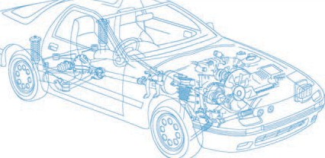

Caledonian Cables

Automotive Cable

FLRYK

Application and Description:

This PVC insulated low-tension automotive cable is used in motorcycles and other motor vehicles for starting ,charging,lighting,signal and instrument panel circuits.

Cable Construction:


Copper conductor PVC insulation

Conductor:Cu-ETP1 bare according to DIN EN 13602 Insulation:PVC insulation(cold resistant) Standard:ISO 6722 Class B
Special properties:

Cold bending test according to ISO 6722 at –50 °C.

Short-term and long-term ageing according to ISO 6722, Class B.

Technical Parameters:

Operating temperature: –50°C to +105°C

 | Conductor Construction |  |  | Insulation | Cable
Nominal cross- section | No. and Dia. of Wires | Diameter  of Conductor max. | Electrical resistance at 20°C max. | Nominal thickness | Overall Diameter Min. | Overall Diameter Max. | Weight approx.
mm2 | No./mm | mm | mΩ/m | mm | mm | mm | kg/km
1x0.50 | 16 /0.21 | 1.0 | 37.7 | 0.22 | 1.4 | 1.6 | 7
1x1.00 | 32/0.21 | 1.4 | 18.5 | 0.30 | 2.3 | 2.1 | 12
1x1.50 | 30/0.26 | 1.7 | 12.7 | 0.24 | 2.2 | 2.4 | 17
1x2.50 | 50/0.26 | 2.1 | 7.6 | 0.70 | 3.5 | 3.7 | 33

Note: Other configurations, sizes, colors and length not specified herein are available upon request.

20 www.caledonian-cables.co.uk www.addison-cables.com

