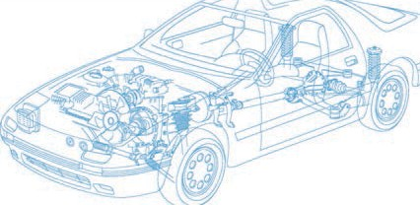

Caledonian Cables

Automotive Cable

FLRYW-A

Application and Description:

This PVC insulated single-core cable is used as low-tension electric wire for automobiles.

Cable Construction:


Copper conductor PVC insulation

Conductor:Cu-ETP1 bare according to DIN EN 13602

Insulation:PVC Standard:ISO 6722 Class C Special properties: Heat resistant cable
Suitable for application inside the engine compartment

Technical Parameters:

Operating temperature: –50°C to +125°C

 | Conductor Construction |  |  | Insulation | Cable
Nominal  cross- section | No. and Dia. of Wires | Diameter  of Conductor max. | Electrical  resistance at 20°C max. | Nominal thickness | Overall Diameter Min. | Overall Diameter Max. | Weight approx.
mm2 | No./mm | mm | mΩ/m | mm | mm | mm | kg/km
1x0.35 | 7/0.26 | 0.8 | 54.4 | 0.20 | 1.2 | 1.3 | 5
1x0.50 | 19/0.19 | 1.0 | 37.1 | 0.22 | 1.4 | 1.6 | 7
1x0.75 | 19/0.23 | 1.2 | 24.7 | 0.24 | 1.7 | 1.9 | 9
1x1.00 | 19/0.26 | 1.35 | 18.5 | 0.24 | 1.9 | 2.1 | 11
1x1.25 | 19/0.30 | 1.7 | 14.9 | 0.24 | 2.1 | 2.3 | 12
1x1.50 | 19/0.32 | 1.7 | 12.7 | 0.24 | 2.2 | 2.4 | 16
1 x2.00 | 19/0.38 | 2.0 | 9.42 | 0.28 | 2.5 | 2.8 | 22
Note: Other configurations, sizes, colors and length not specified herein are available upon request.

www.caledonian-cables.co.uk www.addison-cables.com 23

