
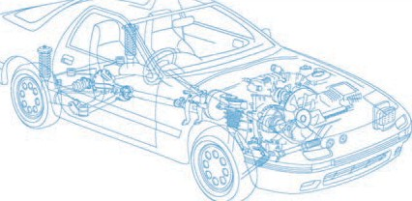

Caledonian Cables

Automotive Cable

FLYK

Application and Description:

This PVC insulated automotive cable is used for cars, trucks and other vehicles.

Cable Construction:


Copper conductor PVC insulation

Conductor:Cu-ETP1 bare according to DIN EN 13602 Insulation:PVC insulation(Cold resistant) Standard:ISO 6722 Class B
Special properties:

Cold bending test according to ISO 6722 at –50 °C.

Short-term and long-term ageing according to ISO 6722, Class B.

Technical Parameters:

Operating temperature: –50°C to +105°C

 | Conductor Construction |  |  | Insulation | Cable
Nominal cross- section | No. and Dia. of Wires | Diameter  of Conductor max. | Electrical  resistance at 20°C max. | Nominal thickness | Overall Diameter Min. | Overall Diameter Max. | Weight approx.
mm2 | No./mm | mm | mΩ/m | mm | mm | mm | kg/km
1x0.50 | 28 /0.16 | 1.1 | 37.7 | 0.6 | 2.0 | 2.3 | 9
1x0.75 | 42/0.16 | 1.3 | 25.1 | 0.6 | 2.2 | 2.5 | 12
1x1.00 | 57/0.16 | 1.5 | 18.8 | 0.6 | 2.4 | 2.7 | 15
1x1.50 | 84/0.16 | 1.8 | 12.7 | 0.6 | 2.7 | 3.0 | 20
1x2.50 | 140/0.16 | 2.3 | 7.54 | 0.7 | 3.5 | 3.9 | 32

18 www.caledonian-cables.co.uk www.addison-cables.com

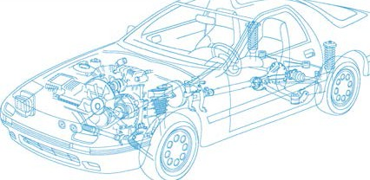
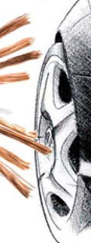
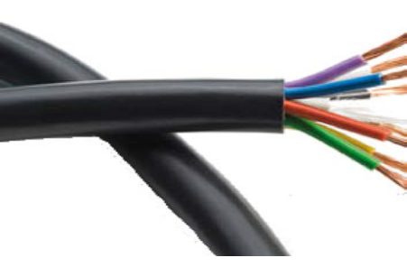
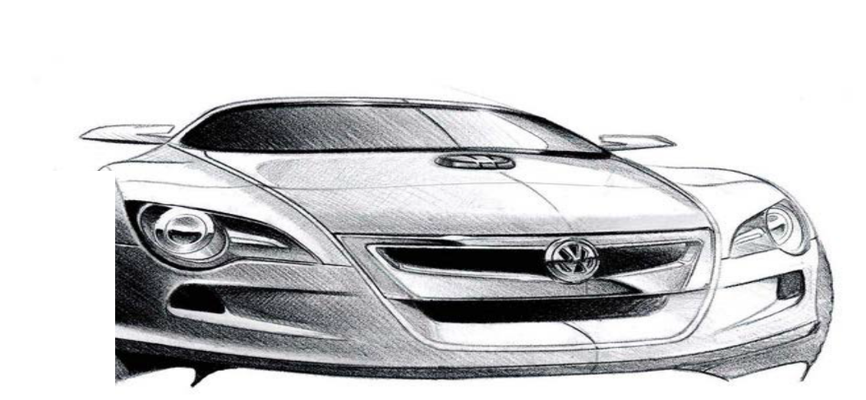

Caledonian Cables

Automotive Cable

 | Conductor Construction |  |  | Insulation | Cable
Nominal cross- section | No. and Dia. of Wires | Diameter of Conductor max. | Electrical  resistance at 20°C  max. | Nominal thickness | Overall Diameter Min. | Overall Diameter Max. | Weight approx.
mm2 | No./mm | mm | mΩ/m | mm | mm | mm | kg/km
1x4.00 | 196/0.16 | 3.3 | 4.71 | 0.8 | 4.5 | 4.9 | 53
1x4.5 | 84/0.16 | 1.80 | 12.7 | 0.6 | 2.7 | 3.0 | 23
1x6.00 | 294/0.16 | 4.2 | 3.14 | 0.8 | 5.3 | 6.0 | 76
1x10.00 | 455/0.16 | 5.2 | 1.85 | 1.0 | 6.7 | 7.3 | 124
1x16.00 | 490/0.21 | 6.7 | 1.16 | 1.0 | 8.2 | 8.8 | 198
1x25.00 | 798/0.21 | 8.0 | 0.74 | 1.2 | 9.9 | 10.5 | 298

Note: Other configurations, sizes, colors and length not specified herein are available upon request.

www.caledonian-cables.co.uk www.addison-cables.com 19

