
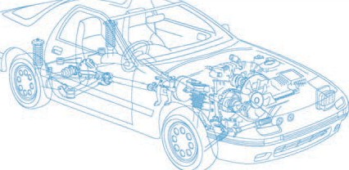

Caledonian Cables

Automotive Cable

FLYOY/FLYKOY

Application and Description:

This PVC insulated low-tension automotive cable is used in motorcycles and other motor vehicles for starting ,charging,lighting,signal and instrument panel circuits.
Cable Construction:


Copper conductor PVC insulation

Conductor:Cu-ETP1 bare according to DIN EN 13602

Insulation:PVC Shtath:PVC, lead free Standard:
ISO 6722 Class B

Special properties:

Flame retardant, Extra flexibility, Cold resistance

Flexible conductors with PVC thick wall insulation with increased mechanical strength

Technical Parameters:

Operating temperature: –40°C to +105°C

 | Conductor Construction |  |  | Insulation | Cable
Nominal cross- section | No. and Dia. of Wires | Diameter of  Conductor max. | Electrical  resistance at 20°C max. | Nominal thickness | Sheath wall thickness | Overall Diameter Min. | Overall Diameter Max. | Weight approx.
mm2 | No./mm | mm | mΩ/m | mm | mm | mm | mm | kg/km
1x4 | 56/0.31 | 2.75 | 4.7 | 0.8 | 2.0 | 8.0 | 8.4 | 123
1x6 | 84/0.31 | 3.3 | 3.1 | 0.8 | 2.0 | 8.6 | 9.0 | 149
1x10 | 80/0.41 | 4.5 | 1.82 | 1.0 | 3.0 | 12.2 | 12.8 | 267
1x16 | 126/0.41 | 6.3 | 1.16 | 1.0 | 2.0 | 11.5 | 12.1 | 279
1x50 | 396/0.41 | 10.5 | 0.368 | 0.8 | 1.4 | 14.5 | 15.1 | 587
1x50 | 1600/0.21 | 10.9 | 0.386 | 0.8 | 1.4 | 14.5 | 15.1 | 592
1x70 | 2200/0.21 | 13.3 | 0.272 | 1.0 | 1.6 | 17.5 | 18.3 | 870
Note: Other configurations, sizes, colors and length not specified herein are available upon request.
36 www.caledonian-cables.co.uk www.addison-cables.com

