
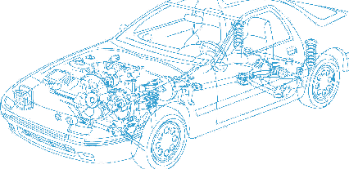

Caledonian Cables

Automotive Cable

FLYW
Application:
This PVC insulated single-core wire is used for automobiles, motorcycles and other motor vehicles. It has good heat resistance.
Construction:


Copper conductor PVC insulation

Conductor: Cu-ETP1 bare according to DIN EN13602
Insulation: PVC
Standard Compliance: ISO 6722
Technical Parameters:
Operating temperature: –40°C to 105°C

 | Conductor |  |  | Insulation | Cable
Nominal Cross- section | No. and Dia. of Wires | Diameter max. | Electrical  Resistance at 20°C  max. | Thickness Wall nom. | Overall Diameter min. | Overall Diameter max. | Weight approx.
mm2 | No./mm | mm | mΩ/m | mm | mm | mm | kg/km
1x0.50 | 16 /0.20 | 1.00 | 37.10 | 0.48 | 2.00 | 2.30 | 8
1x0.75 | 24/0.20 | 1.20 | 24.70 | 0.48 | 2.20 | 2.50 | 11
1x1.00 | 32/0.20 | 1.35 | 18.50 | 0.48 | 2.40 | 2.70 | 15
1x1.50 | 30/0.25 | 1.70 | 12.70 | 0.48 | 2.70 | 3.00 | 20
1x2.50 | 50/0.25 | 2.20 | 7.60 | 0.56 | 3.30 | 3.60 | 32
1x4.00 | 56/0.31 | 2.75 | 4.71 | 0.64 | 4.00 | 4.40 | 48
1x6.00 | 84/0.31 | 3.30 | 3.14 | 0.64 | 4.60 | 5.00 | 68
1x10.00 | 80/0.40 | 4.50 | 1.82 | 0.80 | 6.00 | 6.50 | 117
1x16.00 | 126/0.40 | 5.20 | 1.16 | 0.80 | 8.00 | 8.30 | 193
1x25.00 | 196/0.40 | 6.50 | 0.70 | 1.04 | 10.10 | 10.40 | 274
1x35.00 | 276/0.40 | 7.70 | 0.50 | 1.04 | 11.30 | 11.60 | 397
1x50.00 | 396/0.40 | 9.20 | 0.30 | 1.20 | 13.20 | 13.50 | 547
1x70.00 | 556/0.40 | 11.00 | 0.20 | 1.20 | 15.20 | 15.50 | 769
1x95.00 | 741/0.40 | 14.80 | 0.20 | 1.28 | 17.00 | 18.00 . | 990
*Note: Other configurations, sizes, colors and length not specified herein are available upon request

www.caledonian-cables.co.uk www.addison-cables.com 13

