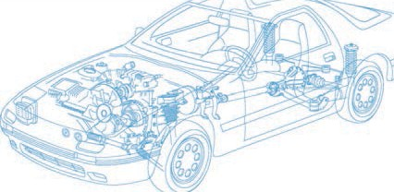

Caledonian Cables

Automotive Cable

FLYWK&FLRYWK

Application and Description:

This PVC insulated low-tension automotive cable is used in motorcycles and other motor vehicles for starting ,charging,lighting,signal and instrument panel circuits.
Cable Construction:


Copper conductor Plasticized PVC insulation

Conductor:Cu-ETP1 bare according to DIN EN 13602 Insulation:Plasticized PVC (heat and cold resistant) Standard:ISO 6722 Class B
Special properties:

Cold bending test according to ISO 6722 at –50 °C.

Short-term and long-term ageing according to ISO 6722, Class B.

Flexible conductors with PVC Thin wall insulation with increased mechanical strength

Technical Parameters:

Operating temperature: –50°C to +105°C

 | Conductor Construction |  |  | Insulation | Cable
Nominal cross- section | No. and Dia. of Wires | Diameter  of Conductor max. | Electrical  resistance at 20°C max. | Nominal thickness | Overall Diameter Min. | Overall Diameter Max. | Weight approx.
mm2 | No./mm | mm | mΩ/m | mm | mm | mm | g/km
1x0.5 | 16/0.20 | 1.0 | 37.1 | 0.28 | 1.4 | 1.6 | 6
1x0.75 | 24/0.20 | 1.2 | 24.7 | 0.6 | 2.2 | 2.5 | 33
1x1.00 | 32/0.20 | 1.4 | 18.5 | 0.3 | 1.8 | 2.1 | 57
1x1.50 | 30/0.25 | 1.7 | 12.7 | 0.3 | 2.2 | 2.4 | 111
1x2.50 | 50/0.25 | 2.1 | 7.6 | 0.7 | 3.3 | 3.7 | 278

Note: Other configurations, sizes, colors and length not specified herein are available upon request.

www.caledonian-cables.co.uk www.addison-cables.com 35

