
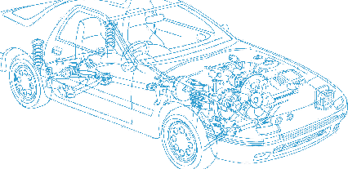

Caledonian Cables

Automotive Cable

FLYY
Application:
This PVC insulated, PVC sheathed low tension multi-cores cable is used for automobiles, motorcycles and other motor vehicles.
Construction:




Copper conductor PVC insulation
PVC sheath

Conductor: Cu-ETP1 bare or tinned according to DIN EN13602
Insulation: PVC
Sheath: PVC
Standard Compliance: ISO 6722
Technical Parameters:
Operating temperature: –40 °C to +150 °C

 | Conductor |  |  | Insulation |  | Cable
Nominal Cross- section | No. and Dia. of Wires | Diameter max. | Electrical  Resistance at 20°C Bare/tinned Max. | Thickness Wall nom. | Diameter of Core | Sheath Thickness | Overall Diameter min. | Overall Diameter max. | Weight approx.
mm2 | No./mm | mm | mΩ/m | mm | mm | mm | mm | mm | kg/km
2x 0.50 | 16/0.21 | 1.00 | 37.10/38.20 | 0.50 | 1.75 | 0.50 | 4.30 | 4.70 | 31
2x 0.75 | 24/0.21 | 1.20 | 24.70/25.40 | 0.60 | 2.30 | 0.50 | 5.40 | 5.80 | 48
2x 1.00 | 32/0.21 | 1.35 | 18.50/19.10 | 0.60 | 2.50 | 0.80 | 6.40 | 6.80 | 65
2x 1.50 | 30/0.26 | 1.70 | 12.70/13.00 | 0.60 | 2.75 | 0.90 | 7.00 | 7.50 | 83
3x 0.50 | 16/0.21 | 1.00 | 37.10/38.20 | 0.50 | 2.10 | 0.60 | 5.80 | 6.20 | 53
3x 0.75 | 24/0.21 | 1.20 | 24.70/25.40 | 0.60 | 2.30 | 0.60 | 5.70 | 6.30 | 60
3x 1.00 | 32/0.21 | 1.35 | 18.50/19.10 | 0.60 | 2.50 | 0.90 | 6.90 | 7.50 | 81
3x 1.50 | 30/0.26 | 1.70 | 12.70/13.00 | 0.60 | 2.65 | 0.70 | 6.90 | 7.50 | 98

*Note: Other configurations, sizes, colors and length not specified herein are available upon request.

20 www.caledonian-cables.co.uk www.addison-cables.com

