
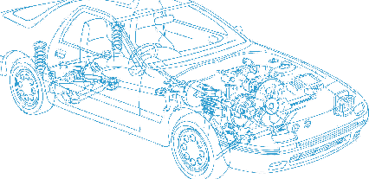

Caledonian Cables

Automotive Cable

FLYY
Application:
This PVC insulated single-core unshielded low-tension wire is used for automobiles, Motorcycles and other motor vehicles.
Construction:


Copper conductor PVC insulation PVC sheath

Conductor: Cu-ETP1 bare according to DIN EN 13602
Insulation: PVC
Sheath: PVC
Standard Compliance: ISO 6722
Technical Parameters:
Operating temperature: –40°C to 90°C

 | Conductor |  |  | Insulation |  | Cable
Nominal Cross- section | No. and Dia. of Wires | Diameter max. | Electrical  Resistance at 20°C max. | Thickness Wall nom. | Diameter of Core | Sheath Thickness Nom. | Overall Diameter min. | Overall Diameter max. | Weight approx.
mm2 | No./mm | mm | mΩ/m | mm | mm | mm | mm | mm | kg/km
1x0.50 | 16/0.21 | 1.00 | 37.10 | 0.60 | 2.10 | 0.40 | 2.70 | 3.10 | 14
1x0.75 | 24/0.21 | 1.20 | 24.70 | 0.60 | 2.30 | 0.40 | 3.00 | 3.30 | 17
1x1.00 | 32/0.21 | 1.35 | 18.50 | 0.60 | 2.50 | 0.40 | 3.20 | 3.60 | 20
1x1.50 | 30/0.26 | 1.70 | 12.70 | 0.60 | 2.80 | 0.50 | 3.70 | 4.10 | 28
1x2.00 | 40/0.26 | 2.00 | 9.42 | 0.60 | 3.00 | 0.50 | 3.90 | 4.30 | 33
1x2.50 | 50/0.26 | 2.20 | 7.60 | 0.70 | 3.50 | 0.50 | 4.30 | 4.80 | 41
*Note: Other configurations, sizes, colors and length not specified herein are available upon request.

12 www.caledonian-cables.co.uk www.addison-cables.com

