
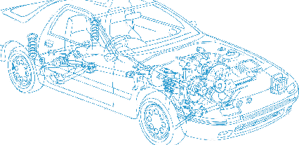

Caledonian Cables

Automotive Cable

FLYZ
Application:
This PVC insulated multi-cores cable is used in internal wiring in automobile where high flexibility, thermo and mechanical strength are required.
Construction:



PVC insulation Copper conductor

Conductor:
Cu-ETP1 bare according to DIN EN13602
Insulation: Plasticized (PVC)
Standard Compliance: ISO 6722
Technical Parameters:
Operating temperature: –25 °C to +90 °C

 | Conductor |  |  | Insulation |  | Cable
Nominal Cross- section | No. and Dia. of Wires | Diameter max. | Electrical  Resistance at 20°C  max. | Thickness Wall nom. | Diameter of Core | Diameter Width | Diameter Height | Weight approx.
mm2 | No./mm | mm | mΩ/m | mm | mm | mm | mm | kg/km
2 x0.50 | 16/0.21 | 1.00 | 37.10 | 0.50 | 2.10 | 4.40±0.20 | 2.10±0.15 | 20
2 x0.75 | 24/0.21 | 1.20 | 24.70 | 0.60 | 2.35 | 4.70±0.30 | 2.35±0.15 | 23
2 x1.00 | 32/0.20 | 1.50 | 19.50 | 0.60 | 2.55 | 5.10±0.30 | 2.60±0.15 | 32
2 x1.50 | 48/0.26 | 1.70 | 12.70 | 0.60 | 2.80 | 5.60±0.30 | 2.80±0.15 | 39
*Note: Other configurations, sizes, colors and length not specified herein are available upon request.

22 www.caledonian-cables.co.uk www.addison-cables.com

