
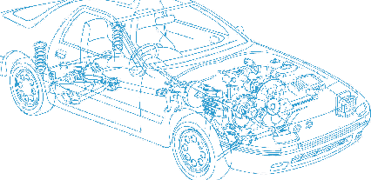

Caledonian Cables

Automotive Cable

GPT
Application:
This PVC insulated single-core cable is used in automotive applications for general circuit wiring and
automotive or marine applications where 105°C is required.
Construction:


Copper conductor PVC insulation

Conductor: Soft-annealed copper according to ASTM B3
Insulation: PVC
Standard Compliance: SAE J1128
Technical Parameters:
Operating temperature: –40 °C to +80 °C

 | Conductor |  |  | Insulation |  | Cable
Size | Nominal  Cross- section | No. and Dia. of Wires | Diameter max. | Thickness  Wall min. | Thickness  Wall  nom. | Overall  Diameter max. | Weight approx.
AWG | mm2 | No./mm | mm | mm | mm | mm | kg/km
22* | 1 x 0.35 | 7/0.25 | 0.76 | - | 0.58 | 2.10 | 7
20 | 1 x 0.50 | 7/0.32 | 0.97 | 0.41 | 0.58 | 2.40 | 10
18 | 1 x 0.80 | 16/0.25 | 1.17 | 0.41 | 0.58 | 2.50 | 12
18 | 1 x 0.80 | 19/0.23 | 1.17 | 0.41 | 0.58 | 2.50 | 12
16 | 1 x 1.00 | 19/0.28 | 1.45 | 0.41 | 0.58 | 2.90 | 17
14 | 1 x 2.00 | 19/0.36 | 1.80 | 0.41 | 0.58 | 3.20 | 25
12 | 1x 3.00 | 19/0.45 | 2.29 | 0.46 | 0.66 | 3.80 | 38
10 | 1 x 5.00 | 19/0.57 | 2.87 | 0.55 | 0.79 | 4.70 | 59
8** | 1 x 8.00 | 19/0.73 | 3.26 | 0.66 | 0.94 | 6.00 | 96
*for Ford ESF M1L56-A Applications only

** For SAE J1128 and UTMS applications only

*Note: Other configurations, sizes, colors and length not specified herein are available upon request.

40 www.caledonian-cables.co.uk www.addison-cables.com

