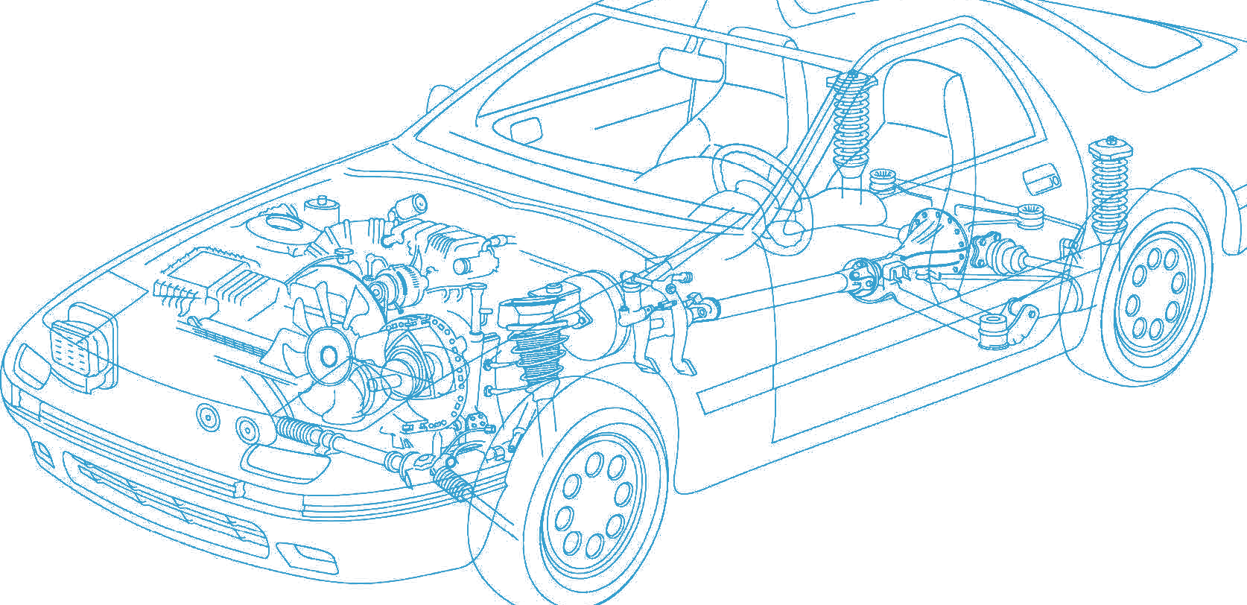

Caledonian Cables

Automotive Cable

HDT

Application:

This PVC insulated single-core cable is used for automobiles, motorcycles and other motor vehicles.

Construction:


Copper conductor PVC insulation

Conductor: Soft-annealed copper according to ASTM B3

Insulation: PVC

Standard Compliance: SAE J1128

Technical Parameters:
Operating temperature: –40 °C to +85 °C

 | Conductor |  |  | Insulation |  | Cable
Size | Nominal  Cross- section | No. and Dia. of Wires | Diameter max. |  | Thickness  Wall nom. | Overall  Diameter max. | Weight Approx.
AWG | mm2 | no./mm | mm |  | mm | mm | kg/km
20 | 1x0.50 | 7/0.31 | 1.00 |  | 0.91 | 2.80 | 14
18 | 1x0.80 | 16/0.26 | 1.50 |  | 0.94 | 3.00 | 20
16 | 1x1.00 | 19/0.29 | 1.50 |  | 1.02 | 3.50 | 25
14 | 1x2.00 | 19/0.36 | 1.80 |  | 1.04 | 3.90 | 33
12 | 1x3.00 | 19/0.45 | 2.30 |  | 1.17 | 4.60 | 49
10 | 1x5.00 | 19/0.57 | 3.00 |  | 1.17 | 5.30 | 71
8 | 1x8.00 | 49/0.45 | 3.70 |  | 1.40 | 6.50 | 98

*Note: Other configurations, sizes, colors and length not specified herein are available upon request.

www.caledonian-cables.co.uk www.addison-cables.com 71

