
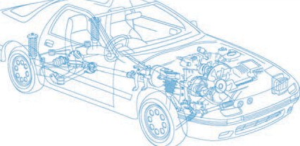

Caledonian Cables

Automotive Cable

SGX

Application and Description:

This XLPO insulated low-tension automotive cable is used in motorcycles and other motor vehicles for starting ,charging,lighting,signal and instrument panel circuits.

Cable Construction:


Copper conductor XLPO insulation

Conductor:Soft-annealed copper according to ASTM B Insulation:XLPO(Cross-Linked Polyolefin) Standard:
SAE J 1127

Special properties:

Flame retardant
Highly resistant against acids,lyes,petrol and diesel

Technical Parameters:

Operating temperature: –40°C to +125°C

Conductor Construction |  |  |  | Insulation
Size | Nominal  cross- section | No. and Dia. of Wires | Diameter of  Conductor max. | Nominal thickness | Overall  Diameter Max. | Weight approx.
AWG | mm2 | No./mm | mm | mm | mm | kg/km
6 | 1x13 | 133/0.36 | 4.83 | 1.52 | 8.6 | 166
4 | 1x19 | 133/0.46 | 6.09 | 1.65 | 10.5 | 257
2 | 1x32 | 133/0.57 | 7.67 | 1.65 | 12.00 | 373
1 | 1x40 | 259/0.46 | 8.49 | 1.65 | 13.00 | 453
1/0 | 1x50 | 1026/0.26 | 9.47 | 1.65 | 14.50 | 545
2/0 | 1x62 | 1254/0.26 | 10.47 | 1.65 | 16.00 | 653
3/0 | 1x81 | 1615/0.26 | 11.98 | 1.98 | 18.50 | 847
4/0 | 1x103 | 2052/0.26 | 13.40 | 1.98 | 20.00 | 1052

Note: Other configurations, sizes, colors and length not specified herein are available upon request.

74 www.caledonian-cables.co.uk www.addison-cables.com

