
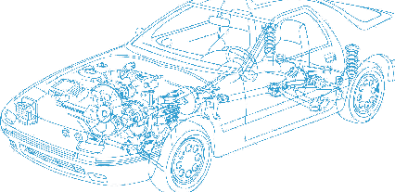

Caledonian Cables

Automotive Cable

SXL
Application:
This XLPE insulated single-core cable is used in automotive applications where higher heat resistance is
required.
Construction:


Copper conductor XLPE insulation

Conductor: Soft-annealed copper according to ASTM B3
Insulation: Polyethylene crosslinked (XLPE)
Standard Compliance: SAE J1128
Technical Parameters:
Operating temperature: –40 °C to +125 °C

 | Conductor |  |  | Insulation |  | Cable
Size | Nominal  Cross- section | No. and  Dia. of Wires | Diameter max. | Thickness  Wall min. | Thickness  Wall  nom. | Overall  Diameter max. | Weight approx.
AWG | mm2 | No./mm | mm | mm | mm | mm | kg/km
20 | 1 x 0.50 | 7/0.32 | 0.97 | 0.52 | 0.74 | 2.80 | 11
18 | 1 x 0.80 | 19/0.23 | 1.17 | 0.53 | 0.76 | 3.00 | 15
16 | 1 x 1.00 | 19/0.28 | 1.45 | 0.57 | 0.81 | 3.40 | 20
14 | 1 x 2.00 | 19/0.36 | 1.80 | 0.62 | 0.89 | 3.90 | 29
12 | 1 x 3.00 | 19/0.45 | 2.29 | 0.66 | 0.94 | 4.60 | 43
10 | 1 x 5.00 | 19/0.57 | 2.87 | 0.73 | 1.04 | 5.30 | 64

*Note: Other configurations, sizes, colors and length not specified herein are available upon request.

www.caledonian-cables.co.uk www.addison-cables.com 43

