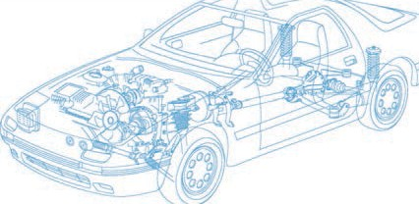

Caledonian Cables

Automotive Cable

WTA

Application and Description:

This PVC insulated low-voltage cable is designed for used at nominal voltage of 60v dc (60V AC rms) or surface vehicles electrical systems.

Cable Construction:


Copper conductor PVC insulation

Conductor:Soft-annealed copper according to ASTM B

Insulation:PVC Ultra-Thin wall according to SAE J 1678 ford WSBM1 L134-A/Chrysler MS 9532/Lear
UTMS 12501/SAEJ 1678

Standard:

SAE J1678

Special properties:

Flexible

Technical Parameters:

Operating temperature: –40°C to +85°C

Conductor Construction |  |  |  | Insulation
Size | Nominal cross- section | No. and Dia. of Wires | Diameter of Conductor max. | Nominal thickness | Overall Diameter Max. | Weight approx.
AWG | mm2 | No./mm | mm | mm | mm | kg/km
22 | 1x0.35 | 7/0.25 | 0.76 | 0.20 | 1.35 | 4
20 | 1x0.50 | 7/0.32 | 0.97 | 0.20 | 1.55 | 7
18 | 1x0.80 | 19/0.23 | 1.17 | 0.20 | 1.75 | 8
16 | 1x1.3 | 19/0.28 | 1.45 | 0.20 | 2.03 | 12
14 | 1x2 | 19/0.36 | 1.8 | 0.20 | 2.39 | 19
12 | 1x3 | 19/0.45 | 2.3 | 0.24 | 3.00 | 30

Note: Other configurations, sizes, colors and length not specified herein are available upon request.

www.caledonian-cables.co.uk www.addison-cables.com 75

