
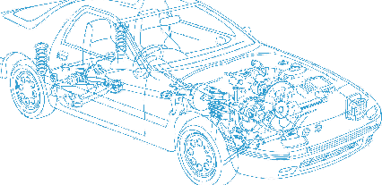

Caledonian Cables

Automotive Cable

AEX/AVX
Application:
This XLPE insulated single-core cable is used for automobiles, motorcycles and other motor vehicles.
Construction:


Copper conductor XLPE(AEX)/PVC(AVX) insulation

Conductor: Cu-ETP1 according to JIS C3102
Insulation: XLPE (AEX)
Crosslinked PVC (AVX)
Standard Compliance: JASO D 608-92
Technical Parameters:
Operating temperature:–40 °C to +120 °C (AEX)
Operating temperature:–40 °C to +100 °C (AVX)

 | Conductor |  |  | Insulation | Cable
Nominal  Cross- section | No. and Dia. of Wires | Diameter max. | Electrical  Resistance at 20°C max. | Thickness Wall nom. | Overall Diameter min. | Overall Diameter max. | Weight approx.
mm2 | No./mm | mm | mΩ/m | mm | mm | mm | kg/km
1 x0.50 | 7/0.32 | 1.00 | 32.70 | 0.50 | 2.00 | 2.20 | 8
1 x0.85 | 11/0.32 | 1.20 | 20.80 | 0.50 | 2.20 | 2.40 | 11
1 x1.25 | 16/0.32 | 1.50 | 14.30 | 0.60 | 2.70 | 2.90 | 16
1 x2.00 | 26/0.32 | 1.90 | 8.80 | 0.60 | 3.10 | 3.40 | 25
1 x3.00 | 41/0.32 | 2.40 | 5.60 | 0.70 | 3.80 | 4.10 | 38
1 x5.00 | 65/0.32 | 3.00 | 3.50 | 0.80 | 4.60 | 4.90 | 59
1 x8.00 | 50/0.45 | 3.70 | 2.30 | 0.80 | 5.30 | 5.60 | 86
1 x15.00 | 84/0.45 | 4.80 | 1.40 | 1.10 | 7.00 | 7.40 | 145
1 x0.50f | 20/0.18 | 1.00 | 36.70 | 0.50 | 2.00 | 2.20 | 8
1 x0.75f | 30/0.18 | 1.20 | 24.40 | 0.50 | 2.20 | 2.40 | 10
1 x 1.25f | 50/0.18 | 1.50 | 14.70 | 0.60 | 2.70 | 2.90 | 16

The "f" in the nominal size column indicates a flexible conductor with a finer wire diameter.

*Note: Other configurations, sizes, colors and length not specified herein are available upon request.

32 www.caledonian-cables.co.uk www.addison-cables.com

