
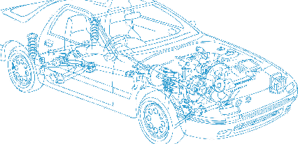

Caledonian Cables

Automotive Cable

AV
Application:
This PVC insulated single-Core cable is used for low voltage circuits in automobiles, vehicles and motorcycles.
Construction:


Copper conductor PVC insulation

Conductor: Cu-ETP1 bare according to D 609-90
Insulation: PVC
Standard Compliance: JIS C 3406
Technical Parameters:
Operating temperature: –40 °C to +85 °C
Intermittent temperature: 120°C

 | Conductor |  |  | Insulation | Cable
Nominal Cross- section | No. and Dia. of Wires | Diameter max. | Electrical  Resistance at 20°C  max. | Thickness Wall nom. | Overall Diameter min. | Overall Diameter max. | Weight approx.
mm2 | No./mm | mm | mΩ/m | mm | mm | mm | kg/km
1 x0.50 | 7/0.32 | 1.00 | 32.70 | 0.60 | 2.20 | 2.40 | 10
1 x0.85 | 11/0.32 | 1.20 | 20.80 | 0.60 | 2.60 | 2.60 | 13
1 x1.25 | 16/0.32 | 1.50 | 14.30 | 0.60 | 2.90 | 2.90 | 17
1 x2.00 | 26/0.32 | 1.90 | 8.81 | 0.60 | 3.40 | 3.40 | 26
1 x3.00 | 41/0.32 | 2.40 | 5.59 | 0.70 | 4.10 | 4.10 | 40
1 x5.00 | 65/0.32 | 3.00 | 3.52 | 0.80 | 4.90 | 4.90 | 62
1 x8.00 | 50/0.45 | 3.70 | 2.32 | 0.90 | 5.80 | 5.80 | 92
1 x10.00 | 63/0.45 | 4.50 | 1.84 | 1.00 | 6.90 | 6.90 | 120
1 x15.00 | 84/0.45 | 4.80 | 1.38 | 1.10 | 7.40 | 7.40 | 160
1 x20.00 | 41/0.80 | 6.10 | 0.89 | 1.10 | 8.30 | 8.80 | 226
1 x30.00 | 70/0.80 | 8.00 | 0.52 | 1.40 | 10.80 | 11.50 | 384
28 www.caledonian-cables.co.uk www.addison-cables.com


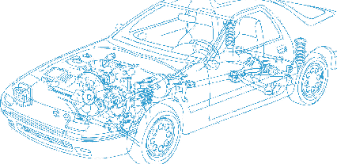
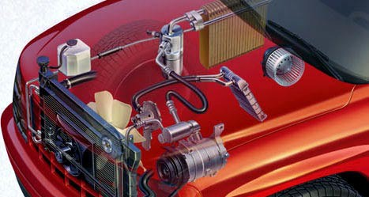

Caledonian Cables

Automotive Cable

 | Conductor |  |  | Insulation | Cable
Nominal Cross- section | No. and Dia. of Wires | Diameter max. | Electrical  Resistance at 20°C  max. | Thickness Wall nom. | Overall Diameter min. | Overall Diameter max. | Weight approx.
mm2 | No./mm | mm | mΩ/m | mm | mm | mm | kg/km
1 x40 | 85/0.80 | 8.60 | 0.43 | 1.40 | 11.40 | 12.10 | 462
1 x50 | 108/0.80 | 9.80 | 0.34 | 1.60 | 13.00 | 13.80 | 583
1 x60 | 127/0.80 | 10.40 | 0.29 | 1.60 | 13.60 | 14.40 | 678
1 x85 | 169/0.80 | 12.00 | 0.22 | 2.00 | 16.00 | 17.00 | 924
1 x100 | 217/0.80 | 13.60 | 0.17 | 2.00 | 17.60 | 18.60 | 1151
1 x0.5f | 20/0.18 | 1.00 | 36.70 | 0.60 | 2.40 | 2.40 | 9
1 x0.75f | 30/0.18 | 1.20 | 24.40 | 0.60 | 2.60 | 2.60 | 12
1 x1.25f | 50/0.18 | 1.50 | 14.70 | 0.60 | 2.90 | 2.90 | 18
1 x2f | 37/0.26 | 1.80 | 9.50 | 0.60 | 3.40 | 3.40 | 25
1 x3f | 61/0.26 | 2.40 | 5.76 | 0.70 | 4.10 | 4.10 | 40

The "f" in the nominal size column indicates a flexible conductor with a finer wire diameter.

*Note: Other configurations, sizes, colors and length not specified herein are available upon request.

www.caledonian-cables.co.uk www.addison-cables.com 29

