
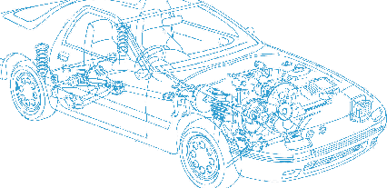

Caledonian Cables

Automotive Cable

AVS

Application:
This PVC insulated single-core cable is used for low voltage circuits in automobiles, vehicles and motorcycles.
Construction:


Copper conductor PVC insulation

Conductor: Cu-ETP1 bare according to D 609-90
Insulation: PVC
Standard Compliance: JASO D 611-94
Technical Parameters:
Operating temperature: –40 °C to +85 °C
Intermittent temperature: 120°C

 | Conductor |  |  | Insulation | Cable
Nominal Cross- section | No. and Dia. of Wires | Diameter max. | Electrical  Resistance at 20°C max. | Thickness Wall nom. | Overall Diameter min. | Overall Diameter max. | Weight approx.
mm2 | No./mm | mm | mΩ/m | mm | mm | mm | kg/km
1 x0.30 | 7/0.26 | 0.80 | 50.20 | 0.50 | 1.80 | 1.90 | 6
1 x0.50 | 7/0.32 | 1.00 | 32.70 | 0.60 | 2.10 | 2.40 | 7
1 x0.85 | 11/0.32 | 1.20 | 20.80 | 0.60 | 2.30 | 2.60 | 10
1 x1.25 | 16/0.32 | 1.50 | 14.30 | 0.60 | 2.60 | 2.90 | 15
1 x2.00 | 26/0.32 | 1.90 | 8.81 | 0.60 | 3.00 | 3.40 | 22
1 x3.00 | 41/0.32 | 2.40 | 5.59 | 0.70 | 3.50 | 3.90 | 42
1 x5.00 | 65/0.32 | 3.00 | 3.52 | 0.80 | 4.50 | 4.90 | 61
1 x0.3f | 15/0.18 | 0.80 | 48.90 | 0.50 | 1.80 | 1.90 | 6
1 x0.5f | 20/0.18 | 1.00 | 36.70 | 0.50 | 2.00 | 2.10 | 8
1 x0.75f | 30/0.18 | 1.20 | 24.40 | 0.50 | 2.20 | 2.30 | 11
1 x1.25f | 50/0.18 | 1.50 | 14.70 | 0.50 | 2.50 | 2.60 | 17
1 x2f | 37/0.26 | 1.80 | 9.50 | 0.50 | 2.90 | 3.10 | 24

The "f" in the nominal size column indicates a flexible conductor with a finer wire diameter.
*Note: Other configurations, sizes, colors and length not specified herein areavailable upon request.

30 www.caledonian-cables.co.uk www.addison-cables.com

