
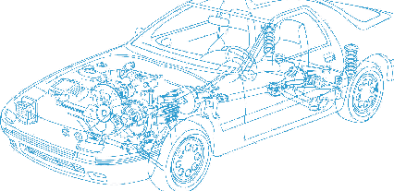

Caledonian Cables

Automotive Cable

AVSS
Application:
This PVC insulated single-core cable is used for low voltage circuits in automobiles, vehicles and Motorcycles.
Construction:


Copper conductor PVC insulation

Conductor: Cu-ETP1 bare according to JIS 3120
Insulation: PVC
Standard Compliance: JASO D 611-94
Technical Parameters:
Operating temperature: –40 °C to +85 °C
Intermittent temperature: 120°C

 | Conductor |  |  | Insulation | Cable
Nominal Cross- section | NO. and Dia. of Wires | Diameter max. | Electrical  Resistance at 20°C max. | Thickness Wall nom. | Overall Diameter min. | Overall Diameter max. | Weight approx.
mm2 | No./mm | mm | mΩ/m | mm | mm | mm | kg/km
1 x 0.30 | 7/0.26 | 0.80 | 50.20 | 0.30 | 1.40 | 1.50 | 5
1 x 0.50 | 7/0.32 | 1.00 | 32.70 | 0.30 | 1.60 | 1.70 | 7
1 x 0.85 | 19/0.24 | 1.20 | 21.70 | 0.30 | 1.80 | 1.90 | 10
1 x 1.25 | 19/0.29 | 1.50 | 14.90 | 0.30 | 2.10 | 2.20 | 14
1 x 0.3f | 19/0.16 | 0.80 | 48.80 | 0.30 | 1.40 | 1.50 | 5
1 x 0.5f | 19/0.19 | 1.00 | 34.60 | 0.30 | 1.60 | 1.70 | 7
1 x 0.75f | 19/0.23 | 1.20 | 23.60 | 0.30 | 1.80 | 1.90 | 10
1 x 1.25f | 37/0.21 | 1.50 | 14.60 | 0.30 | 2.10 | 2.20 | 14
1 x 2f | 37/0.26 | 1.80 | 9.50 | 0.40 | 2.60 | 2.70 | 22
The "f" in the nominal size column indicates a flexible conductor with a finer wire diameter.

*Note: Other configurations, sizes, colors and length not specified herein areavailable upon request.

www.caledonian-cables.co.uk www.addison-cables.com 31

