
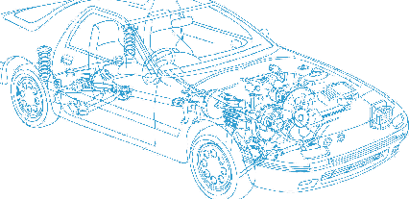

Caledonian Cables

Automotive Cable

GXL
Application:
This XLPE insulated single-core cable is used in automotive applications where higher heat resistance
and small diameter is required.
Construction:


Copper conductor XLPE insulation

Conductor: Soft-annealed copper according to ASTM B3
Insulation: Polyethylene crosslinked (XLPE)
Standard Compliance: SAE J1128
Technical Parameters:
Operating temperature: –40 °C to +125 °C

 | Conductor |  |  | Insulation |  | Cable
Size | Nominal  Cross- section | No. and Dia. of Wires | Diameter max. | Thickness  Wall min. | Thickness  Wall  nom. | Overall  Diameter max. | Weight approx.
AWG | mm2 | No./mm | mm | mm | mm | mm | kg/km
20 | 1 x 0.50 | 19/0.20 | 0.97 | 0.41 | 0.58 | 2.40 | 9
18 | 1 x 0.80 | 19/0.23 | 1.17 | 0.41 | 0.58 | 2.50 | 12
18 | 1 x 0.80 | 16/0.25 | 1.17 | 0.41 | 0.58 | 2.50 | 12
16 | 1 x 1.00 | 19/0.24 | 1.45 | 0.41 | 0.58 | 2.90 | 17
14 | 1 x 2.00 | 19/0.36 | 1.80 | 0.41 | 0.58 | 3.20 | 25
12 | 1 x 3.00 | 19/0.45 | 2.29 | 0.46 | 0.66 | 3.80 | 38
10 | 1 x 5.00 | 19/0.57 | 2.87 | 0.56 | 0.79 | 4.70 | 58

*Note: Other configurations, sizes, colors and length not specified herein are available upon request.

42 www.caledonian-cables.co.uk www.addison-cables.com

