
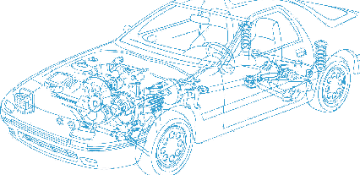

Caledonian Cables

Automotive Cable

TXL
Application:
This XLPE insulated single-core cable is used in automotive applications where higher heat resistance,
small diameter and minimal weight is required.
Construction:


Copper conductor XLPE insulation

Conductor: Soft-annealed copper according to ASTM B
Insulation: Polyethylene crosslinked (XLPE)
Standard Compliance: SAE J1128
Technical Parameters:
Operating temperature: –40 °C to +105 °C

 | Conductor |  |  | Insulation |  | Cable
Size | Nominal  Cross- section | No. and  Dia. of Wires | Diameter max. | Thickness  Wall min. | Thickness  Wall  nom. | Overall  Diameter max. | Weight approx.
AWG | mm2 | No./mm | mm | mm | mm | mm | kg/km
22 | 1 x 0.35 | 7/0.25 | 0.76 | 0.28 | 0.40 | 1.70 | 6
20 | 1 x 0.50 | 7/0.32 | 0.97 | 0.28 | 0.40 | 1.90 | 8
20 | 1 x 0.50 | 19/0.19 | 0.95 | 0.28 | 0.40 | 1.90 | 8
18 | 1 x 0.80 | 16/0.25 | 1.17 | 0.28 | 0.40 | 2.20 | 11
18 | 1 x 0.80 | 19/0.23 | 1.17 | 0.28 | 0.40 | 2.20 | 11
16 | 1 x 1.00 | 19/0.28 | 1.45 | 0.28 | 0.40 | 2.40 | 15
14 | 1 x 2.00 | 19/0.36 | 1.80 | 0.28 | 0.40 | 2.70 | 22
12 | 1 x 3.00 | 19/0.45 | 2.29 | 0.32 | 0.46 | 3.30 | 34
10 | 1 x 5.00 | 19/0.57 | 2.87 | 0.35 | 0.50 | 4.00 | 53
10 | 1 x 5.00 | 100/0.26 | 3.00 | 0.35 | 0.45 | 3.90 | 53
8* | 1 x 8.00 | 49/0.46 | 4.06 | 0.39 | 0.55 | 4.90 | 85

*For SAE J1128 applications only
*Note: Other configurations, sizes, colors and length not specified herein are available upon request.

www.caledonian-cables.co.uk www.addison-cables.com 41

